
FRIDAY 2 OCTOBER 2026  FORTH, HERAKLION

At a glance
Key details
Time | 10:00 – 19:00 (EEST)
Venue | FORTH — Foundation for Research and Technology-Hellas  N. Plastira 100, Vassilika Vouton, GR-700 13 Heraklion, Crete  FORTH Auditorium [Innovation and Advanced Training Hub – New Building]
Registration | space-crete.eu
Programme
Agenda
Time | Session | Speaker
Opening & project overview
10:00 – 10:05 | Welcome address | Prof. Vassilis Charmandaris  Chairman of the BoD, FORTH
10:05 – 10:40 | SPACE-Crete: Vision, structure and roadmap | Prof. Panagiotis Tsakalides  Project Coordinator, FORTH-ICS
10:40 – 11:00 | Industrial partner perspective: OHB-Hellas | Dr. Mathieu Bernou  CTO & Managing Director, OHB-Hellas
11:00 – 11:30 | Coffee break & networking
Advanced partners & European ecosystem
11:30 – 11:50 | Advanced partner perspective: CEA | Michel Berthé  DRF / IRFU — Département d’Astrophysique, CEA
11:50 – 12:10 | Advanced partner perspective: DLR | Dr. Jakob Buchheim  DLR, Germany
12:10 – 12:40 | ESA BIC Greece: Support for space entrepreneurship | Dr. Jorge-A. Sanchez-P.  ESA BIC Greece
12:40 – 14:00 | Lunch break & networking
Thematic sessions
14:00 – 14:45 | Session 1 — Earth Observation & Artificial Intelligence | Dr. Charalampos Kontoes  National Observatory of Athens  Dr. Nektarios Chrysoulakis  FORTH-IACM  Prof. Grigorios Tsagkatakis  FORTH-ICS / University of Crete
14:45 – 15:00 | Break
15:00 – 15:45 | Session 2 — Optical & Quantum Communications | Dr. Wolf von Klitzing  FORTH-IESL  Prof. Dimitris Papazoglou  FORTH-IESL / University of Crete  Dr. Thorsten Siebert  IOF-Fraunhofer, Germany  Prof. Kai Bongs  DLR, Germany
15:45 – 16:00 | Break
16:00 – 16:45 | Session 3 — Funding Opportunities in Space | Vagia Piteli  PRAXI Network  Roula Bachtalia  Head of Venture Banking  Eurobank  Eliso Kotsieva  Entrepreneur Experience Director  Endeavor Greece
Closing & networking
16:45 – 17:00 | Closing remarks & next steps | Prof. Panagiotis Tsakalides  Project Coordinator, FORTH-ICS
17:00 – 19:00 | Evening reception (light drinks & bites)
Before you come
Practical information
Venue  FORTH, Vassilika Vouton — about 15 minutes by taxi from Heraklion city centre, 20 from the airport (HER). City buses to the Voutes / PAGNI campus stop beside FORTH. |  | Catering  Complimentary coffee breaks, lunch, and evening reception drinks for all registered participants.
Accessibility  The venue is wheelchair accessible. Please contact the organisers in advance for any specific access requirements. |  | Photography  Photographs and video may be taken for dissemination purposes. Participants who prefer not to appear should inform the organisers on arrival.
Consortium
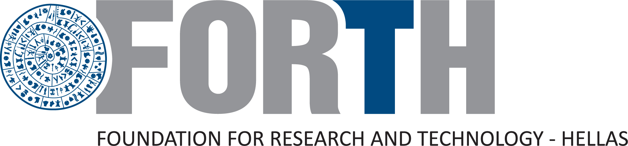 | 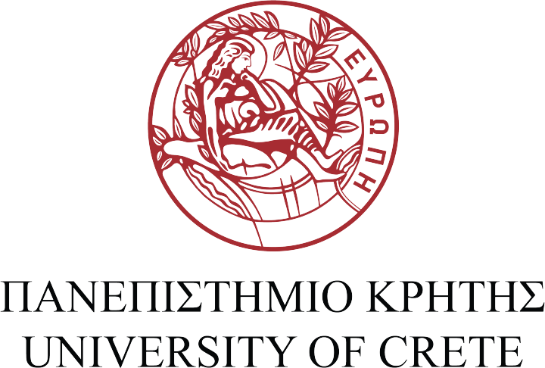 |  | 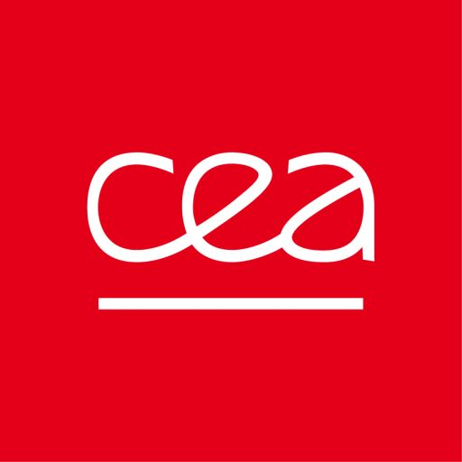 | 
SPACE-Crete is co-funded by the European Union under Horizon Europe (HORIZON-WIDERA-2025-ACCESS-01-01, Teaming for Excellence). Views and opinions expressed are those of the authors only and do not necessarily reflect those of the European Union or the granting authority.

